**Excel Project report Of Road Accident :**

**Path: C:\Users\Dell\Desktop\Sandeep_ Projects_all\Excel projects**

**Requirements Of Client:**

**Stakeholders Involved In this Projects are:**

**File type Used :**

**First data Cleaning :**

Checking null or blank values by applying filter on column heading and freezing headers.

In accident severity there was spelling error of fatal was mention has fetal on some rows so replaced that text for clean data

**Data Processing:**

Inserting new column near day of week for trend line KPI adding column as Month

**=TEXT(B2,"mmm")** *### Month column formula used*

this is the formula we had used here to extract first three letters of month if need whole then type “mmmm” it will show full name of month

**=TEXT(B2,"yyyy")** *### year column formula used added column*

this is the formula we had used here to extract year from date column if need whole then type “yyyy” it will show full year

**Data Analysis & Data Visualization:**

Creating primary KPI

|  |
| --- |
| **Sum of Number_of_Casualties** |
| 417883 |

=(F12/($F$12+$F$13))

formula created for percentage calculation and $ this symbol is given to fix the absolute reference of column ( click function + F4 ) for Fixing formula reference.

**KPI s with doughnut charts created:**

|  |  |  |
| --- | --- | --- |
| Fatal Sevirity |  |  |
| Fatal | 7135 | 0.017074 |
| Others | 410748 | 0.982926 |

|  |  |  |
| --- | --- | --- |
| Serious Sevirity |  |  |
| Serious | 59312 | 14.2% |
| Others | 358571 | 85.8% |

|  |  |  |
| --- | --- | --- |
| Slight Sevirity |  |  |
| Slight | 351436 | 84.1% |
| Others | 66447 | 15.9% |
|  |  |  |

Simultaneously creating dashboard :

1. #222B35 this is colour code used in dashboard background in new sheet and hidden grid lines also
2. Rounded corner shape inserted added container to left side
3. Gone in format and added colour fill with customized colour #8497B0
4. For 4 Kpis Inserting Shapes ctrl + drag
5. Inserting textbox for heading of dashboard
6. Total casulaties added text box and formula is provided to give reference to the = kpi sheet value present in pivot table
7. Then we had inserted timeline of accident according to year slicer to analyze if data is changing simultaneously
8. Given references of different kpi from pivot table
9. Copy paste doughnut charts and give values references in between to reflect
10. Now consolidate in same pivot table with reference to combining cars category in pivot table analyze ribbion and calculate car + hire car in calculated pivot table analyzer
11. Similarly for bus,motorcycle,van,others we are combining data in calculated fields
12. Inserted secondary kpis of vehicles images
13. And added reference text values from pivot table by making dynamic changes in cell reference side by side in pivot table because it will not take direct values from pivoted data so we added extra column but taken same reference to make it dynamic
14. Created new pivot table of monthly trend for 2021 and 2022 speartely which we have created month column while data processing time for trend analysis
15. Make special side table of month and 2021,2022 for reference to dashboard to take values from there
16. Editing built in markers of each line and legends on top
17. Converted values by using ctrl+1 key and chaged into custom 0.0,”K” in thousands to display small

1. Till this this is the work on dashboard will look like

1. Tree map added for road surface and no.of casualties
2. Doughnut chart added for area wise and light type

1. Add timeline slicer on pivot table and add to dashboard filter panel and do report connection to every sheet except monthly trend sheet to connect with each other
2. Customized timeline format
3. Adding icons for link connecttions directly to different sources

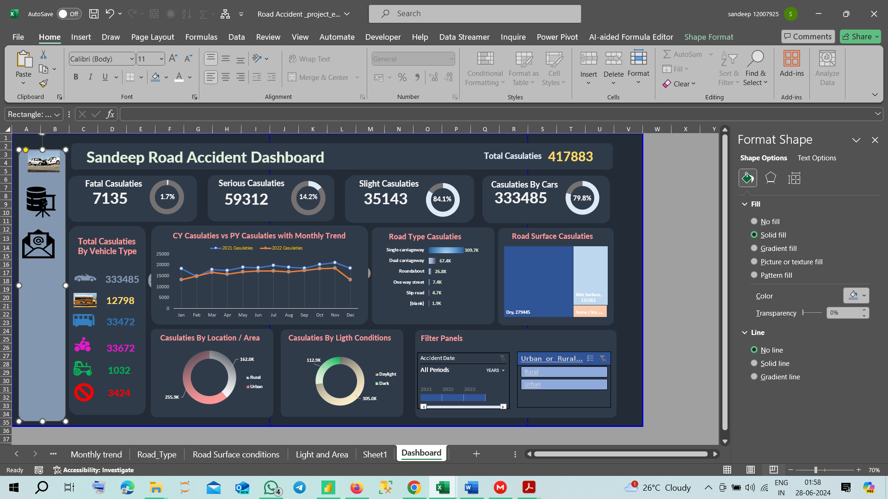

1. Final Dashboard with links to website and different sheets created all done

